Patient Alerts

|  |  |  |  |
| --- | --- | --- | --- |
| Approved By: | Libby Broussard, LeAnne Reilly | Effective Date: | 7/22/2022 |
| Approval Date: | 7/22/2022 | Revised Date: | 12/12/2022 |
| Procedure Location: | Operations > Safety | Number of Pages: | 3 |

Purpose

Our goal is to stay up to date with our pet guests’ needs. This procedure will outline how to input an alert or special notes on a pet’s file.

Audience

Center Manager, Assistant Manager, Supervisor, Customer Service Representatives, Animal Care Attendants, Veterinary Assistants.

General Information

* Some patient alerts will automatically “pop up” when accessing a pet’s file. When this happens, it is important to read over these alerts.
* There will be a standard list of icons to choose from within Gingr.
* If the pet has icons, ensure accurate colored paper or stickers are used for the pet’s Run Card.
* If you need to add a patient alert/pet icon added to the center’s Point-of-Sale system, submit an [IT – Cornerstone – Gingr Support Request](https://it.destpet.com/hc/en-us/requests/new) ticket.

Procedure

This procedure will outline how to manage patient alerts within Gingr and Cornerstone

Patient Alerts in Gingr

1. In Gingr, patient alerts are called “animal icons”. You can add an icon to a pet anytime you can see the pet’s information (their file, on the dashboard, etc.).
2. Click the grey **+** sign to open all available icons.

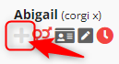

1. Hover over the icon to read more information about the icon.

* Graphical user interface, text, application

  Description automatically generated

1. Once you find the desired icon, left click the icon and add any needed comments.
2. Then, press the **+Add Icon** button.
3. If you need to edit an icon:
   1. Find the Animal’s name (on dashboard, profile, etc) and click on the light gray **+** icon next to their assigned icons.
   2. Icons currently assigned to an animal will show up with a blue highlight. To edit the icon, click on the highlighted icon.
   3. Type in note. If desired, click the box “Create Employee Note?”.
   4. Press the **Save** button.
4. If you need to remove an icon:
   1. Find the Animal’s name (on dashboard, profile, etc) and click on the light gray **+** icon next to their assigned icons.
   2. Icons currently assigned to an animal will show up with a blue highlight. To edit the icon, click on the highlighted icon.
   3. Click on the red **Trash Cash** icon next to the comments field to remove the icon from the pet.
   4. Press the **OK** button on the confirmation.

**Patient Alerts in Cornerstone**

1. In Cornerstone, access the Patient Clipboard.
2. Locate and select the desired patient.
3. Under the patient’s file, select **Prompts/Notes** icon.

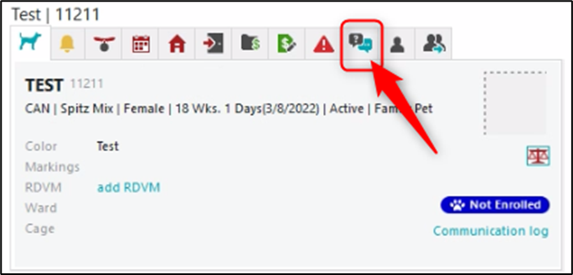

1. Right click and select **Update** button.
2. Locate the desired alert. Select the box to the right of the alert and type in the needed information.
3. Once complete, press the **OK** button.

This alert will now “pop up” anytime the patient’s clipboard (file) is opened/accessed.

References

* [IT – Cornerstone – Gingr Support Request](https://it.destpet.com/hc/en-us/requests/new)

